1) Create one IAM user and assign ec2,s3 full access role.

Create an IAM-user with the name “Techie-user”

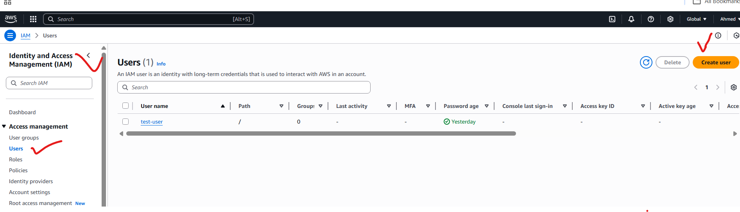

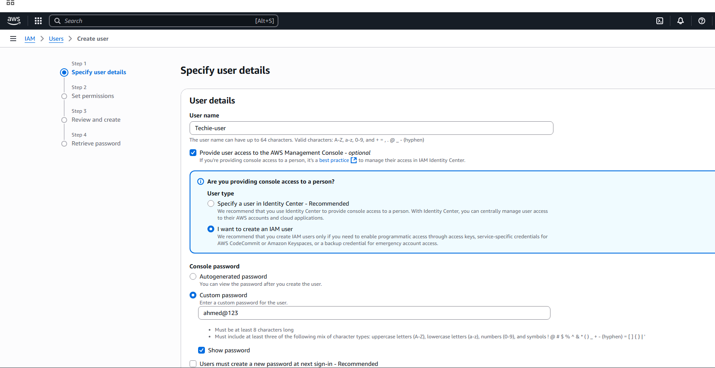

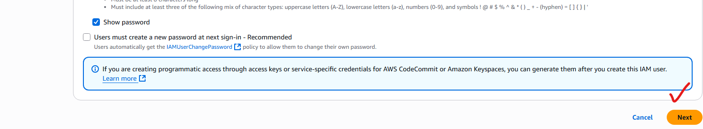

Assing a EC2 and S3 full access:

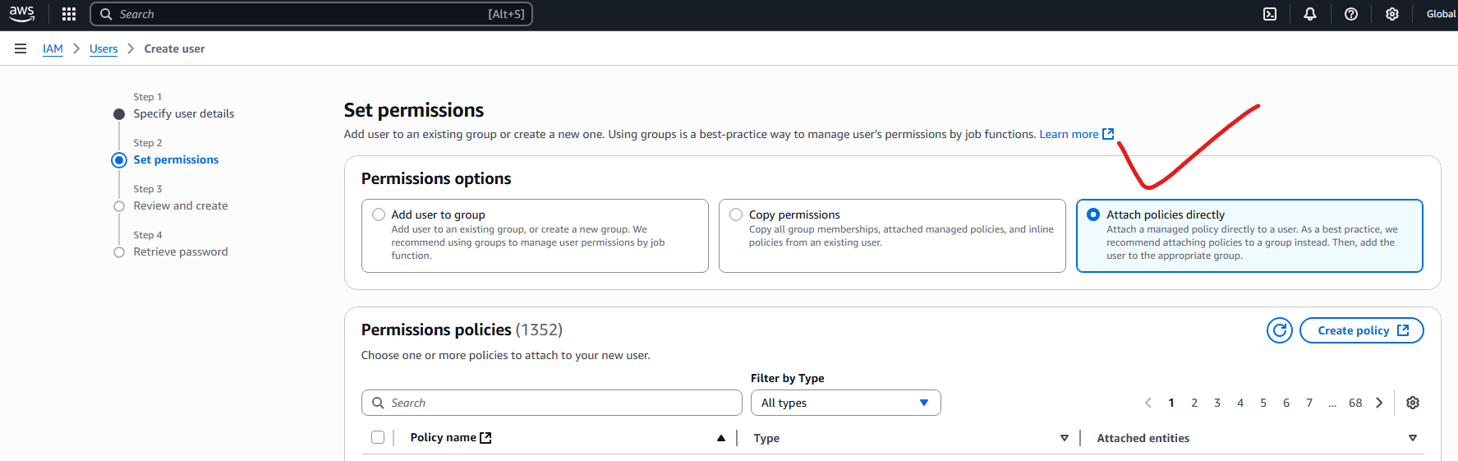

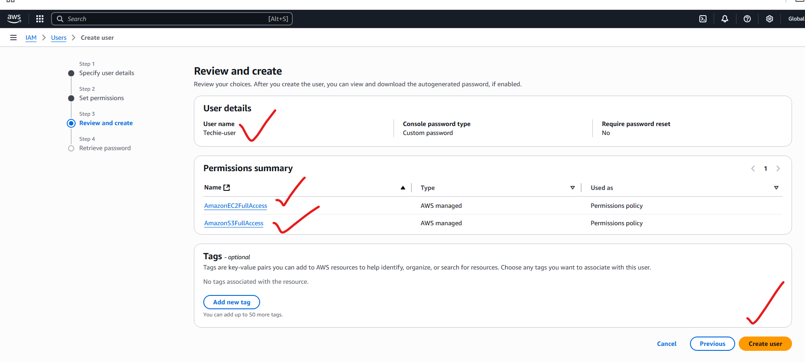

Created a IAM-user with ec2 and s3 full access:

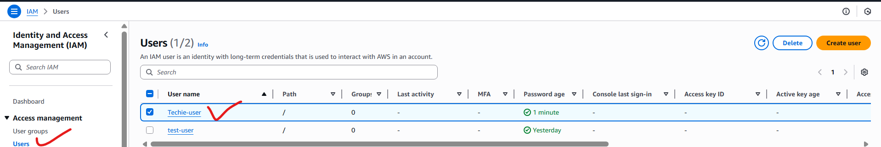

2) Create one Group in IAM and Assign Read access for ec2.

Crating a group:

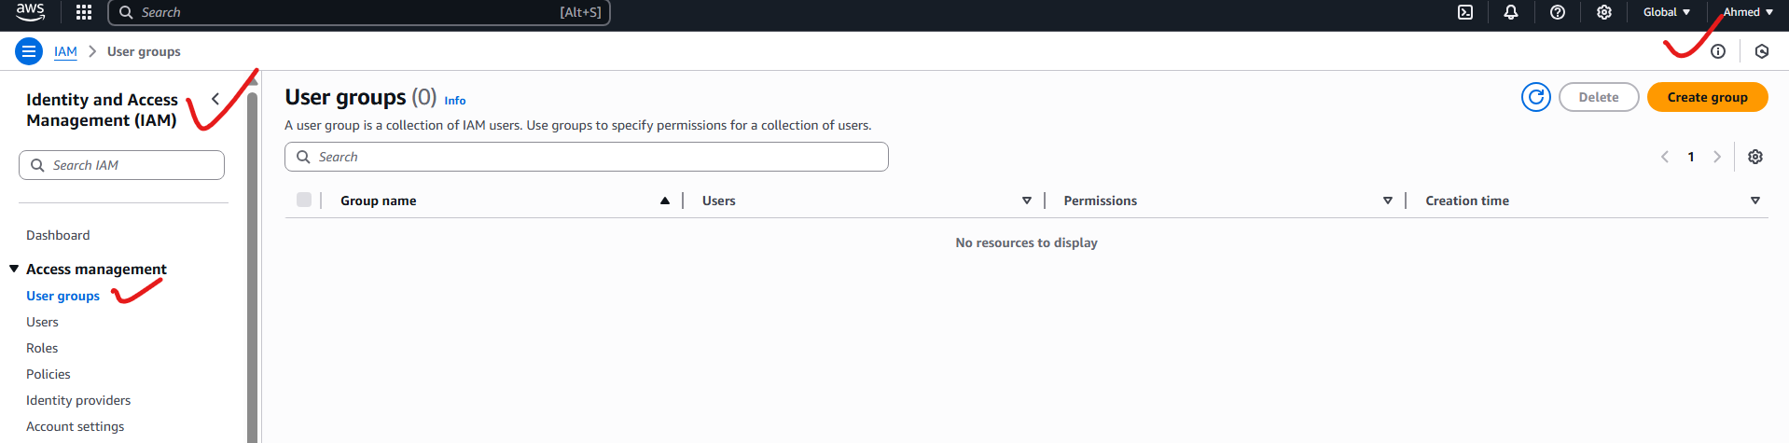

Not selecting the users, because I am just creating a group and assigning ec2 read access:

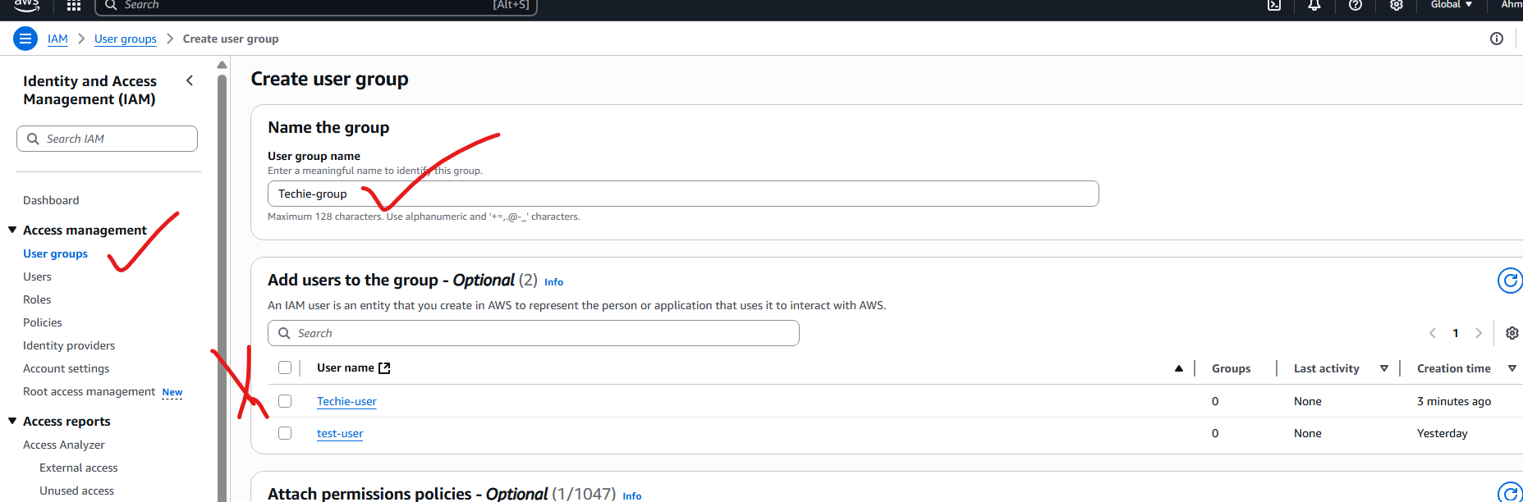



Techie-group-test



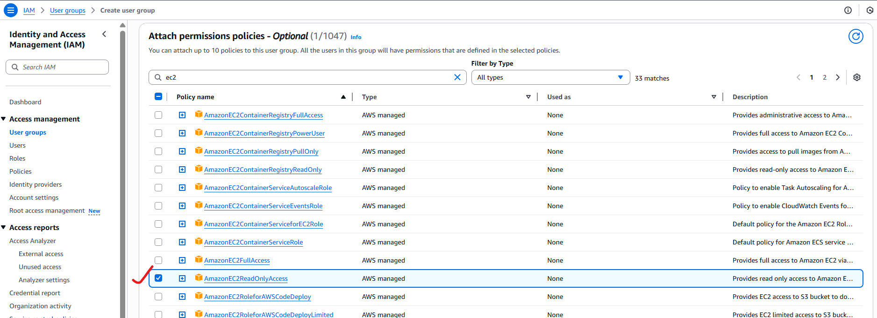

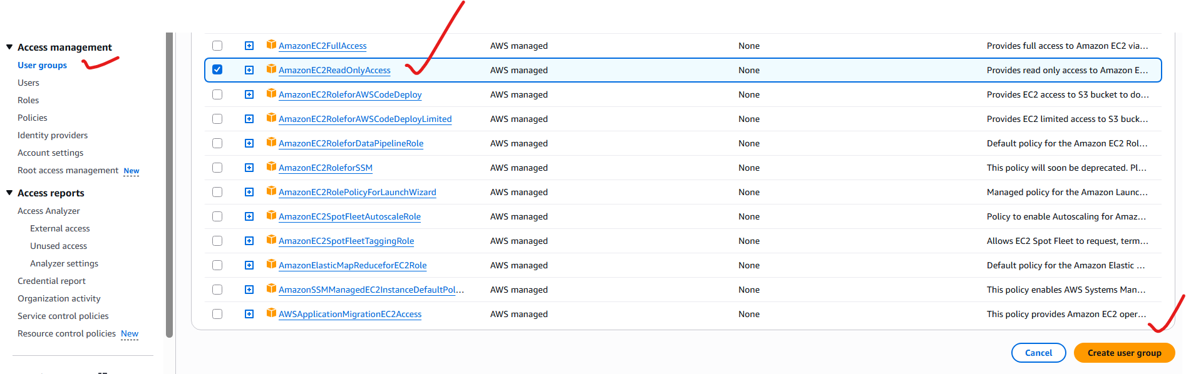

Crated the group:Techie-group-test:

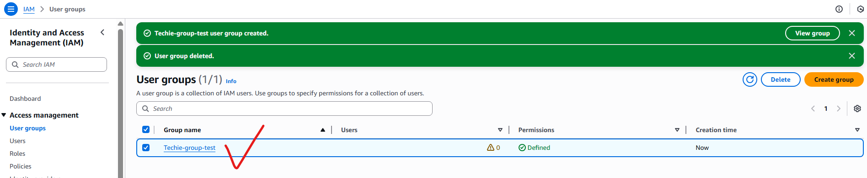

With ec2ReadOnlyAccess permission:

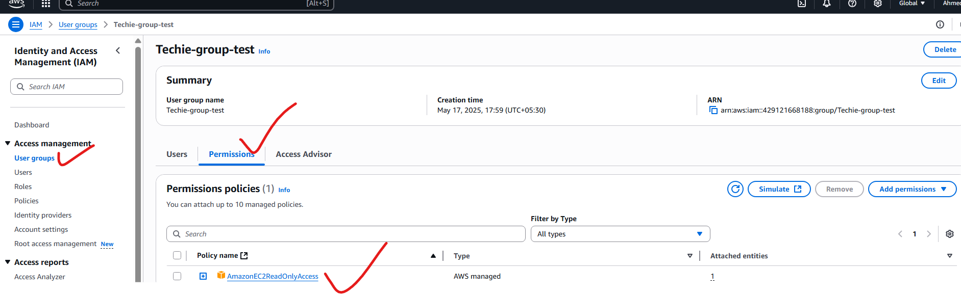

3) Create a new user with name Devops and add to the group created in task2.

Creating a user with the name DevOps:

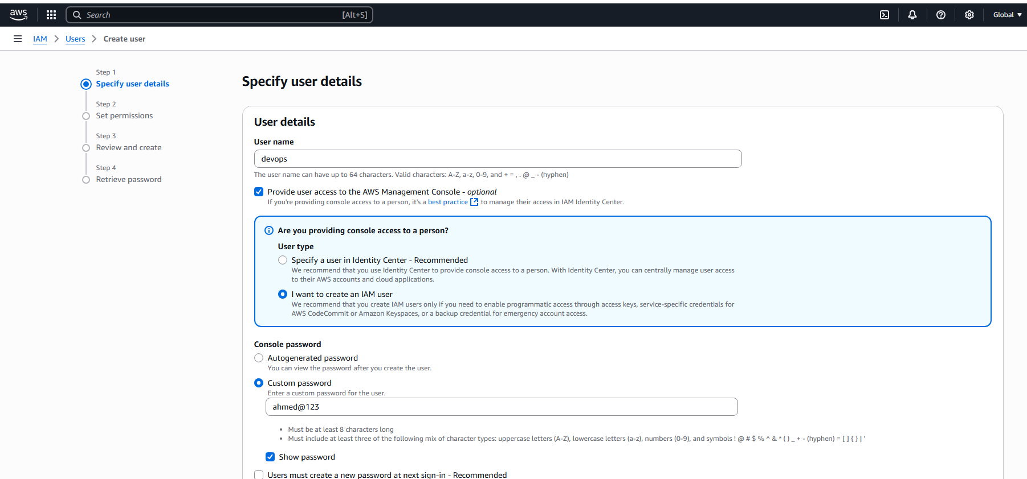

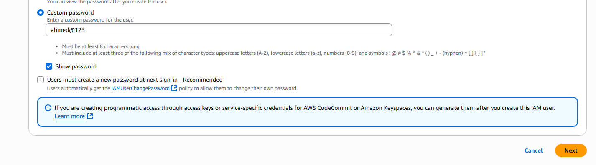

Adding user to the existing group:

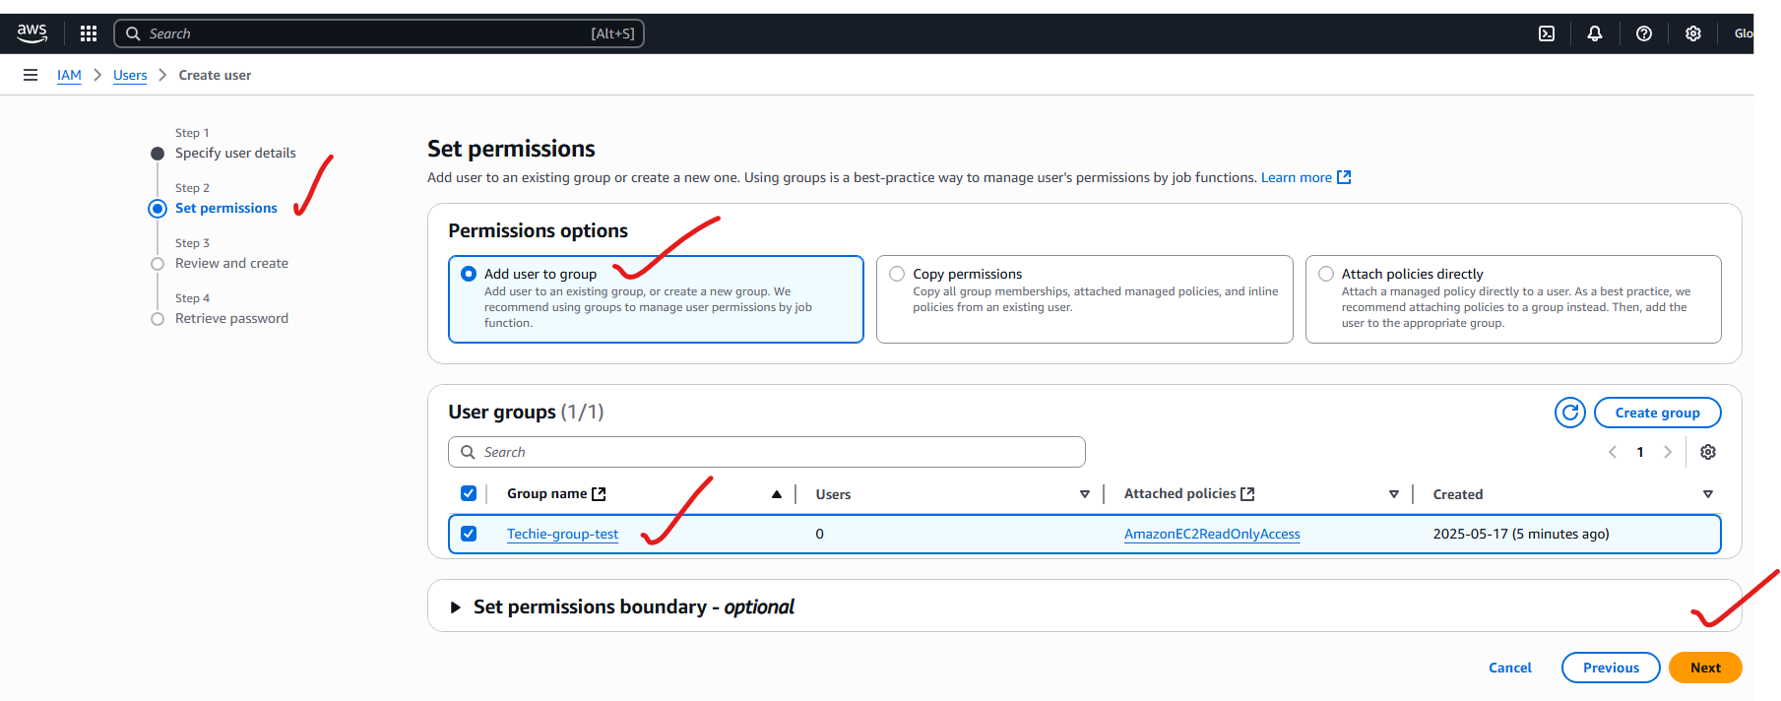

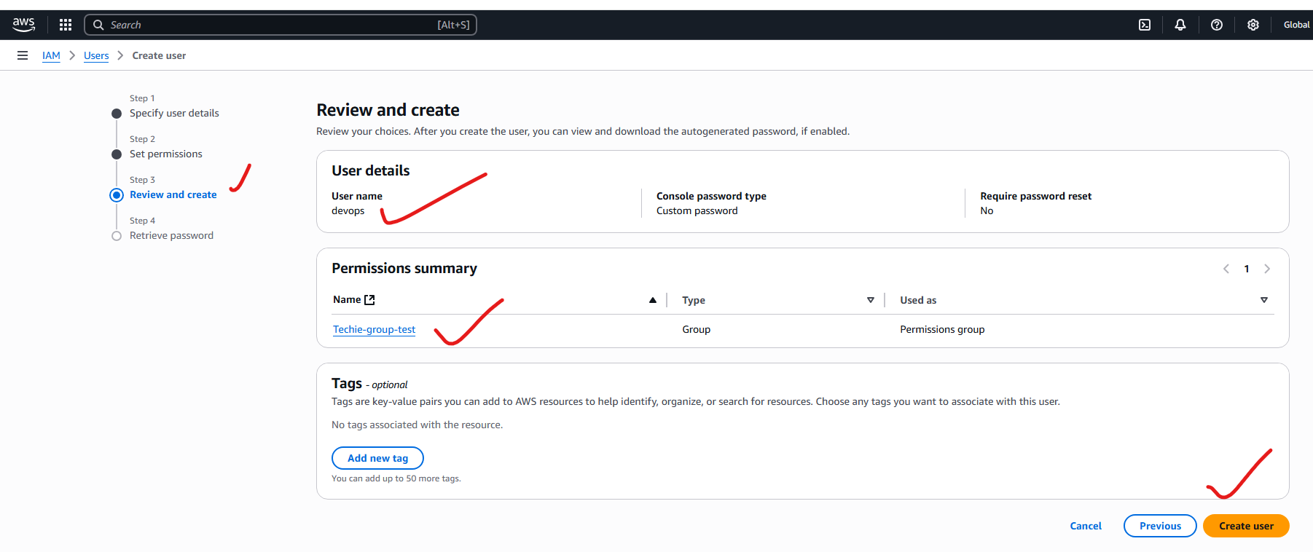

Successfully added the devops user to the group(having ec2 read only permission):

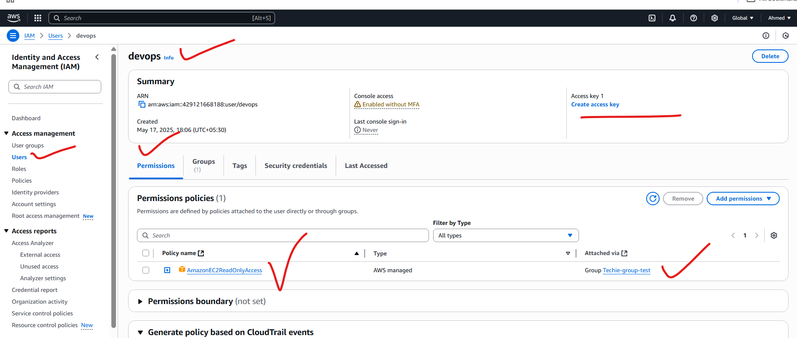

4) Write a bash script to create a IAM user with VPC full access.

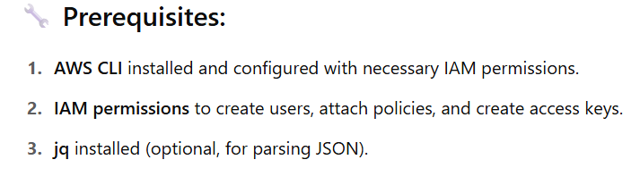

Create a file name with “create_vpc_user.sh”:

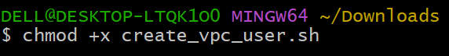

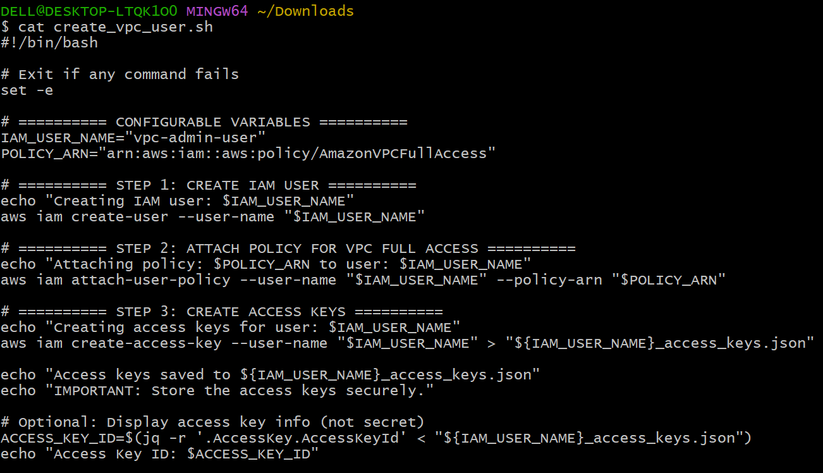



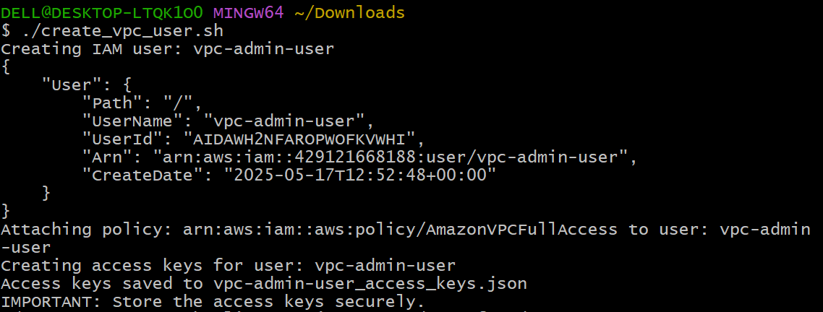



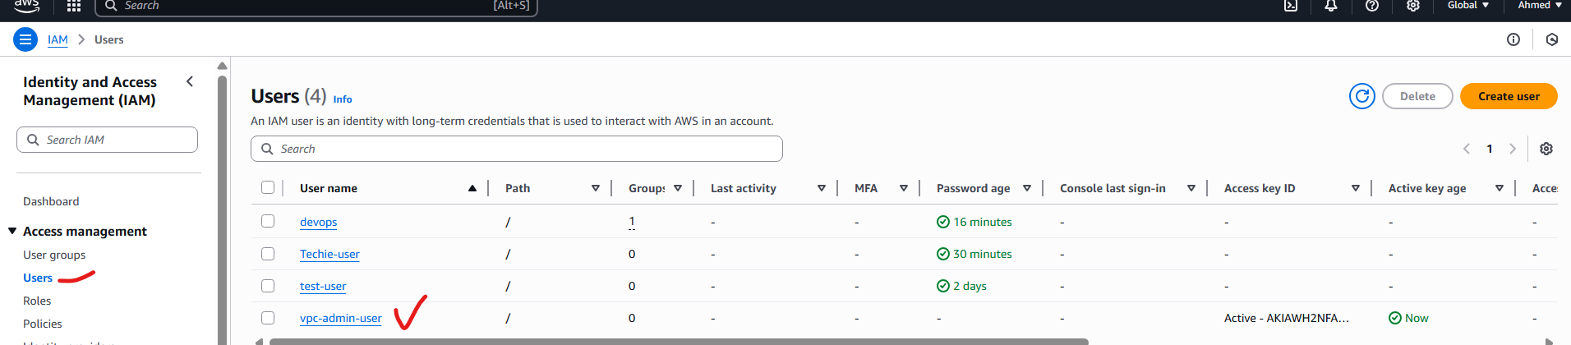

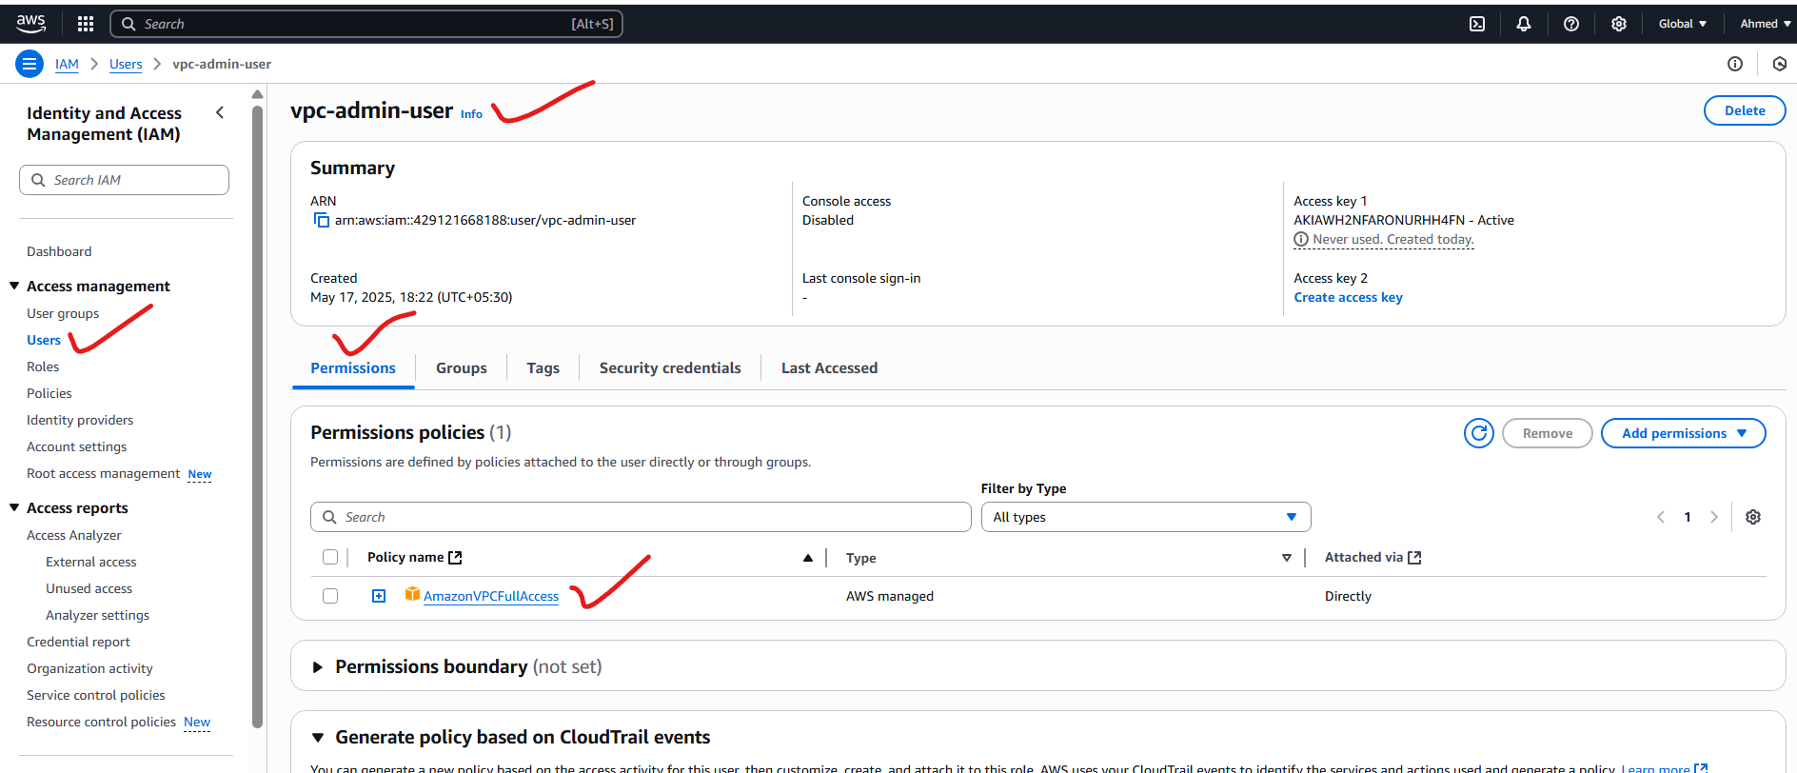

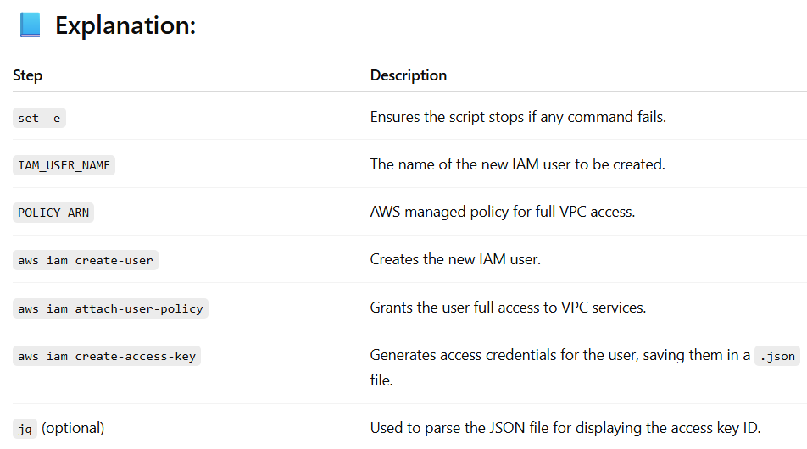

5) Create a IAM policy to access ec2 for a specific user in specific regions only.

First we create our custom policy:

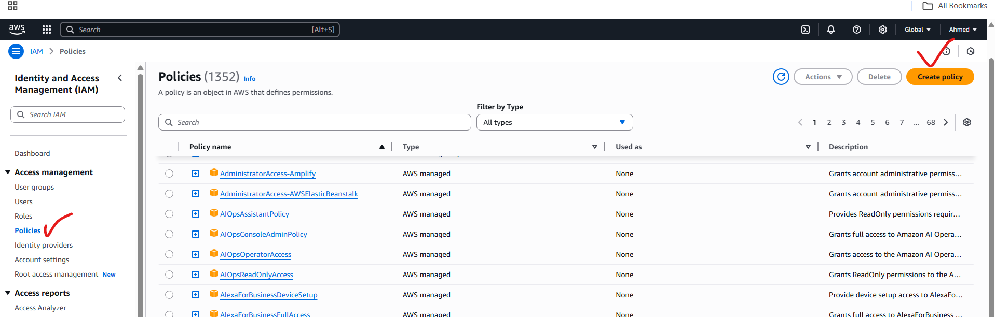

Copy the json script and paste in policy generator:

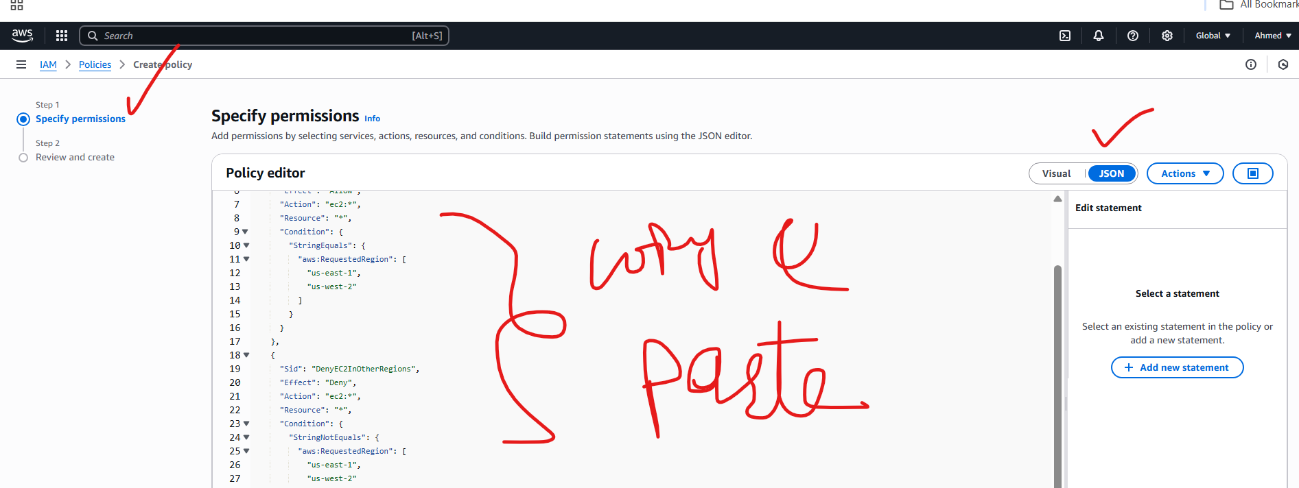

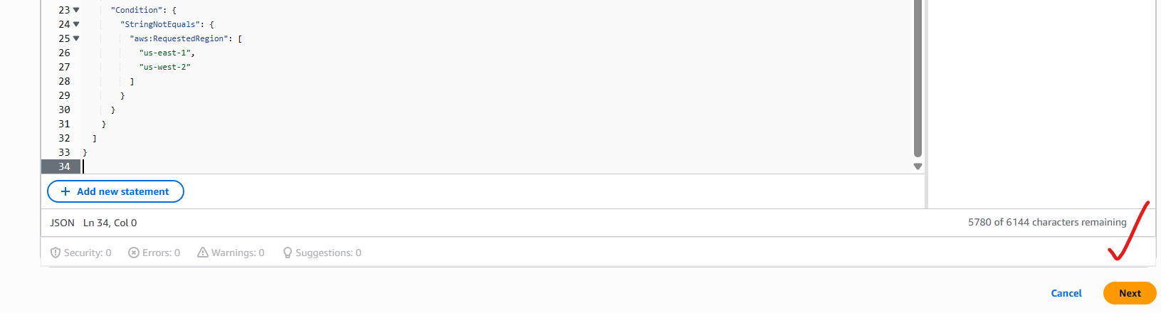

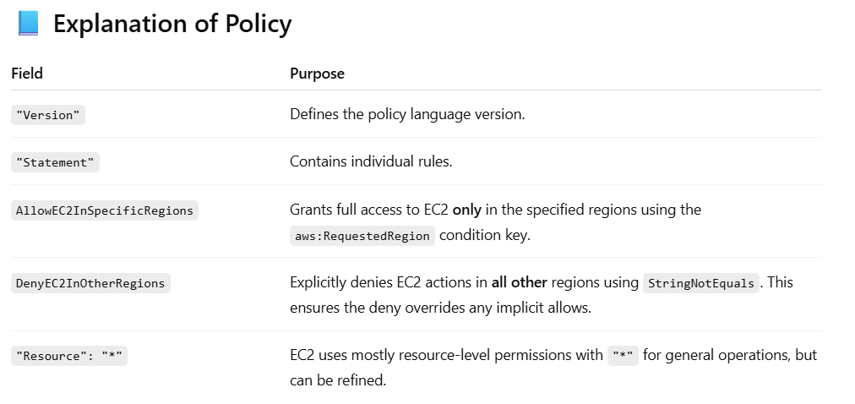

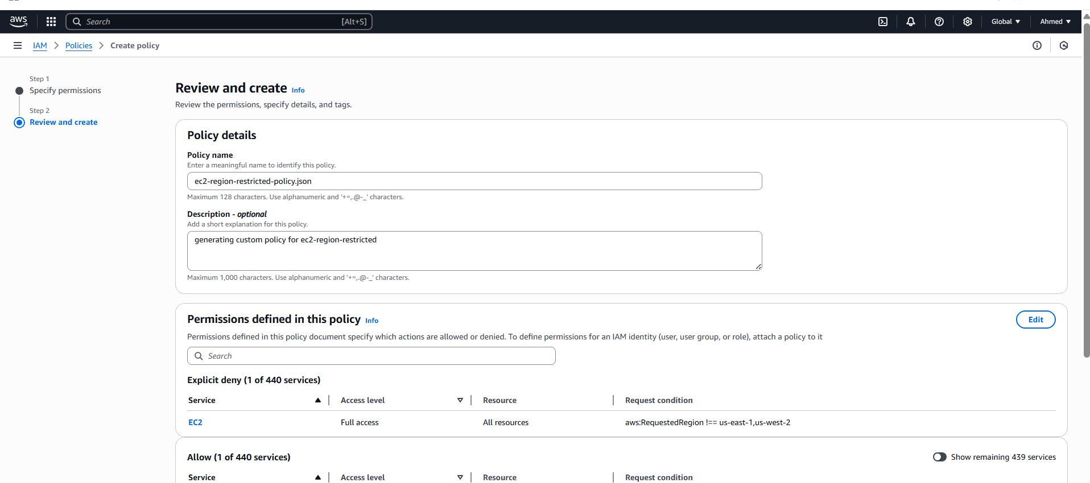

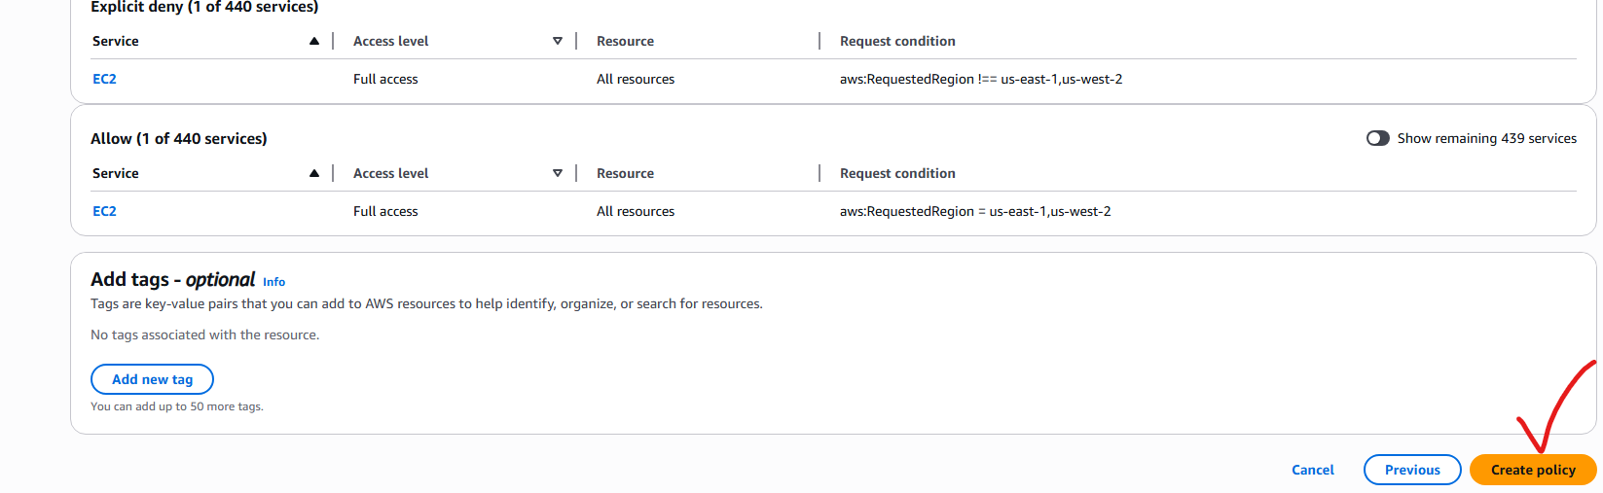

We created our own policy: customer managed

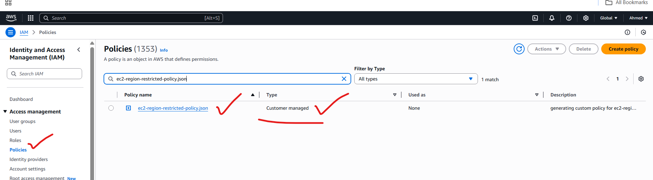

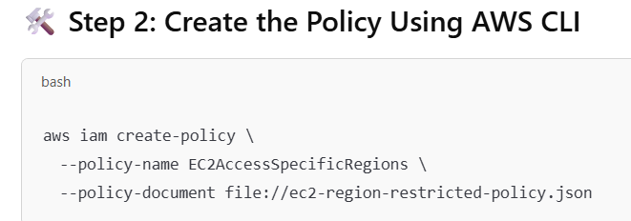

Create one IAM user:

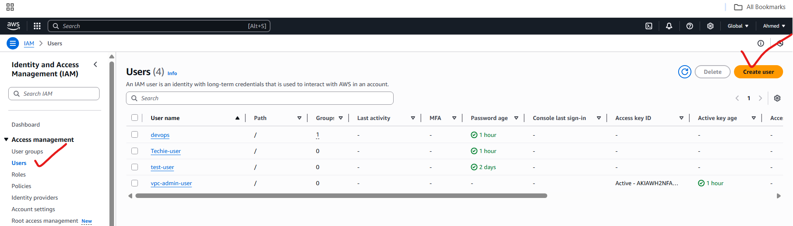

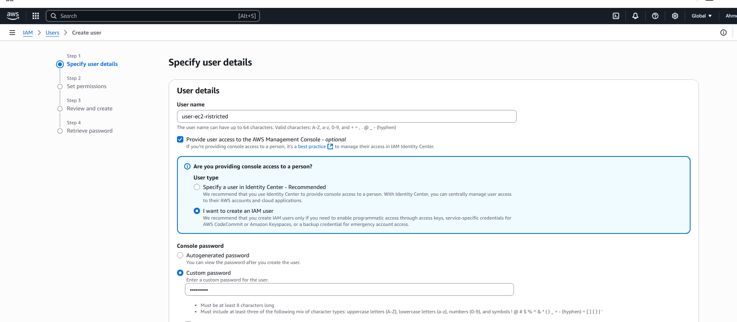

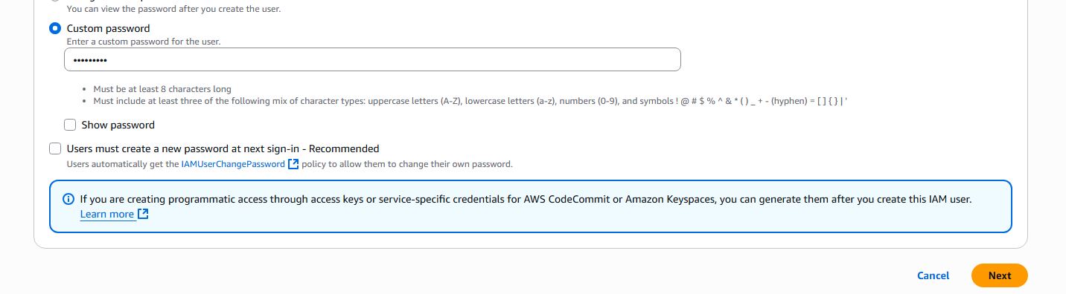

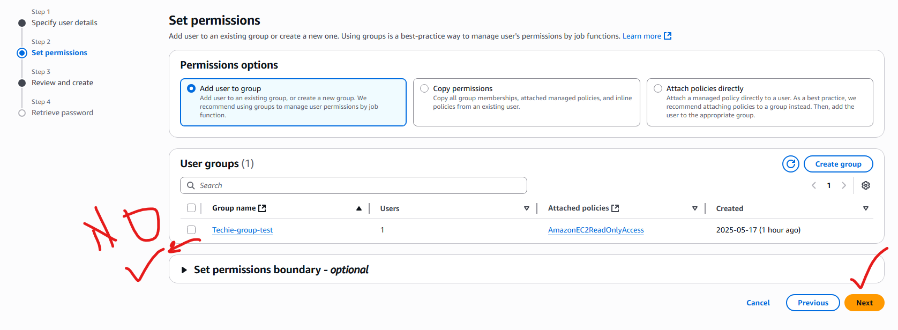

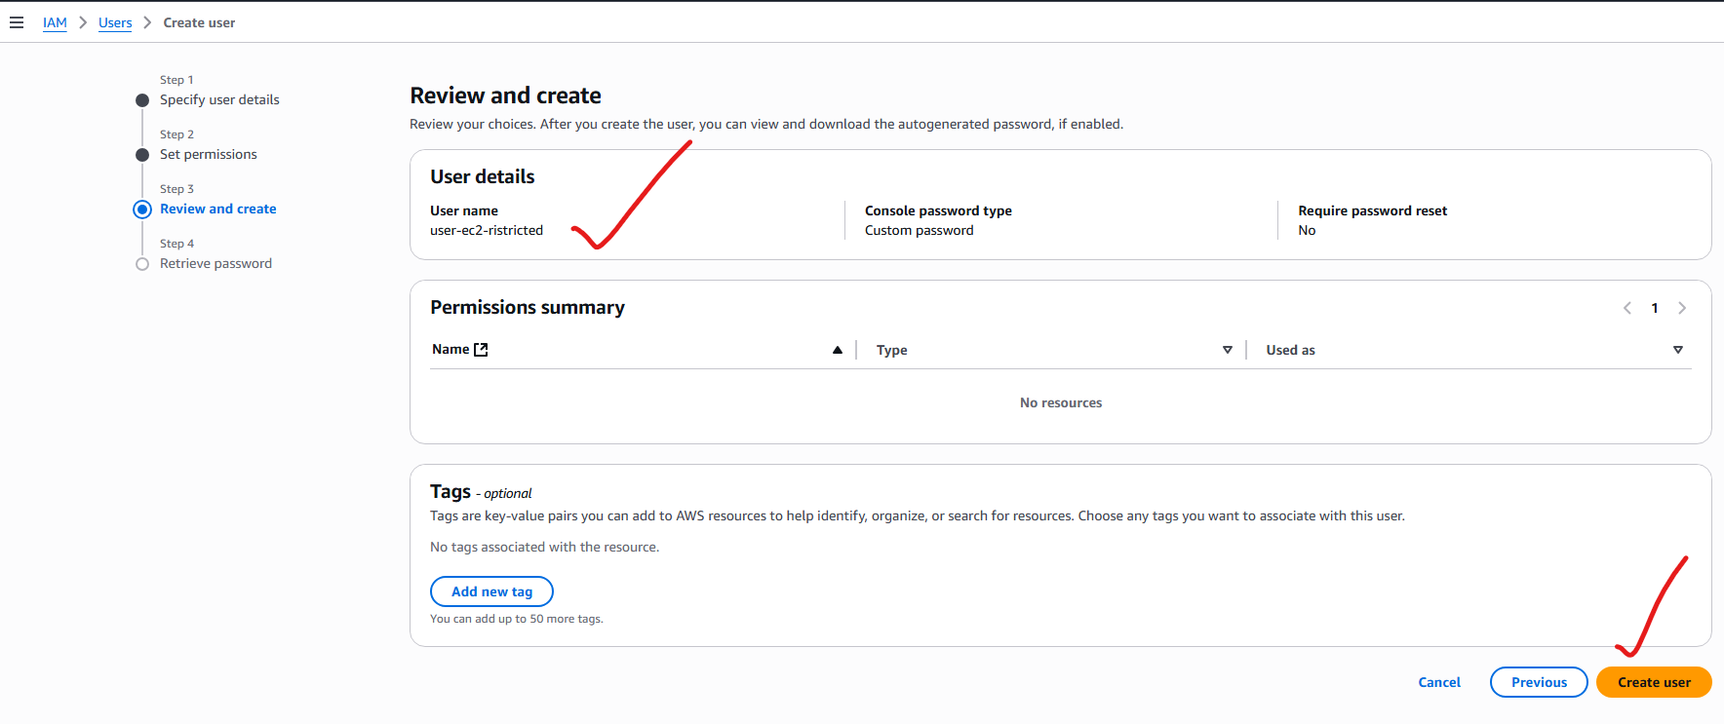

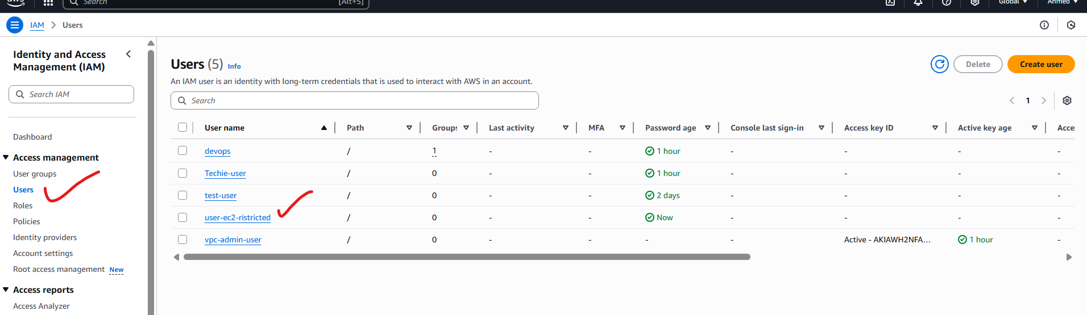

User created successfully:

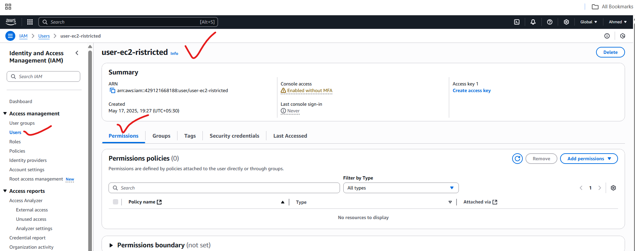

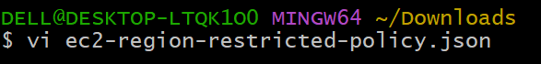

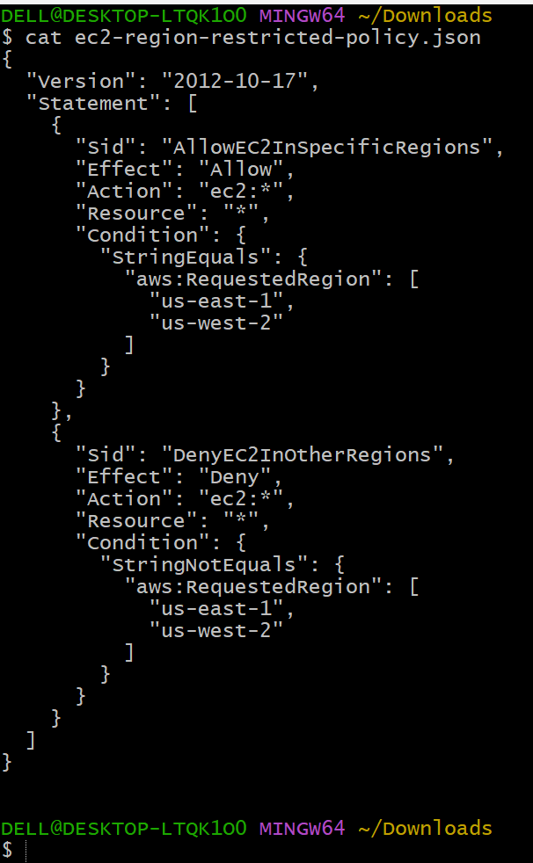

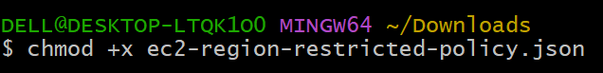

Command for creating policy:

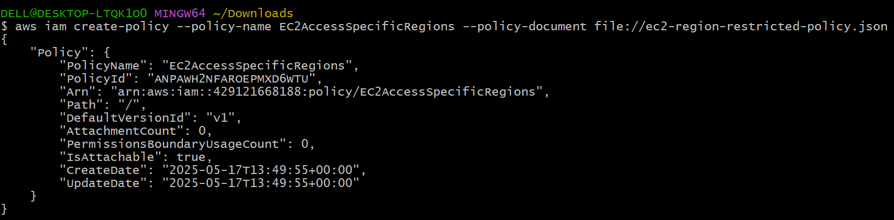

Policy created:

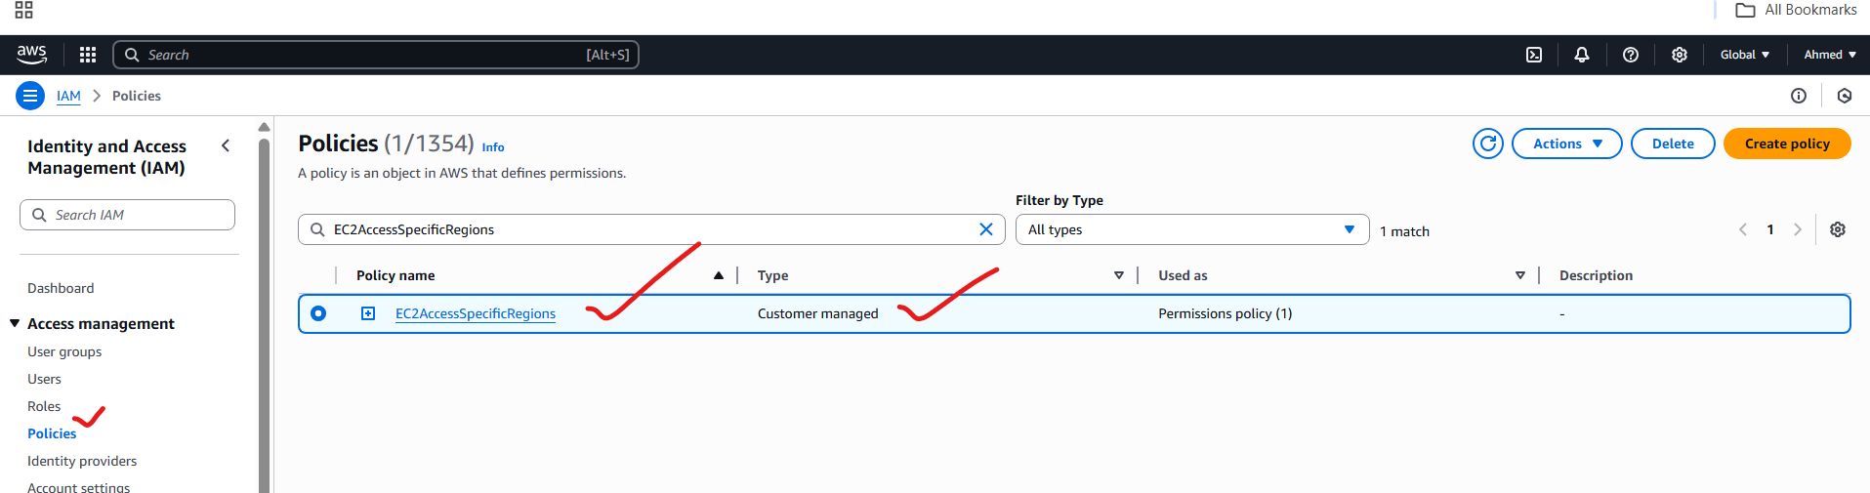



Previously it is not there, but after executing this command we attached our custom policy

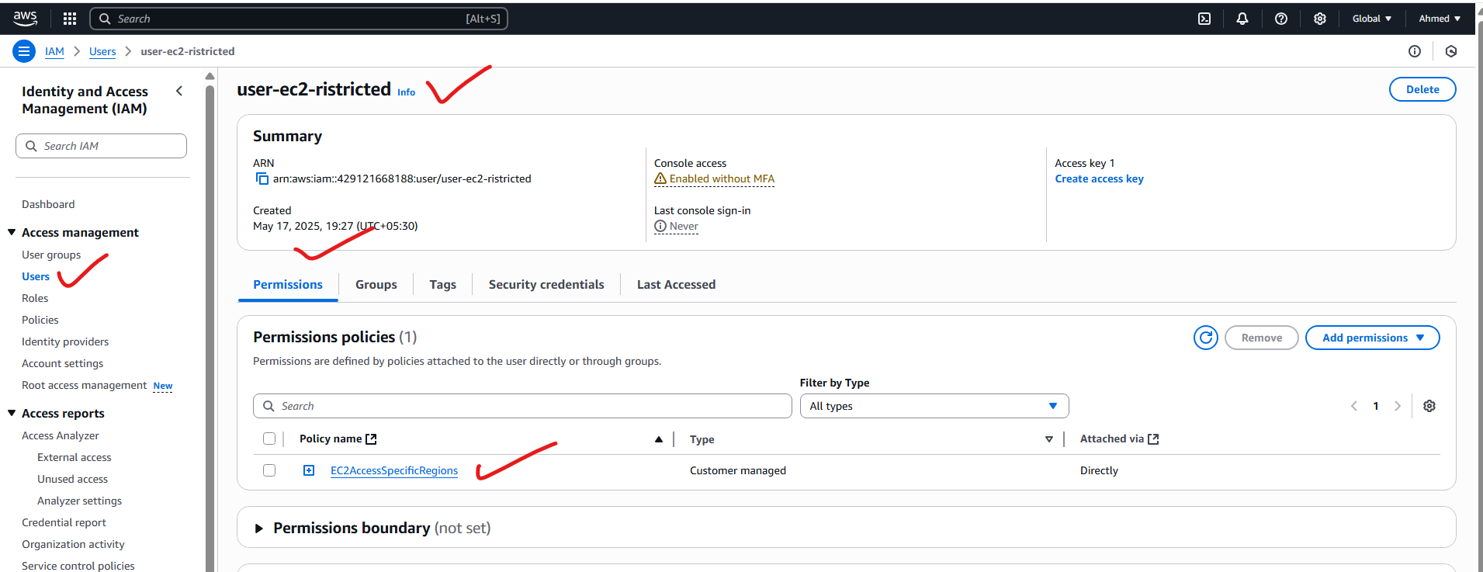

To check the list of users created in AWS IAM: the command is

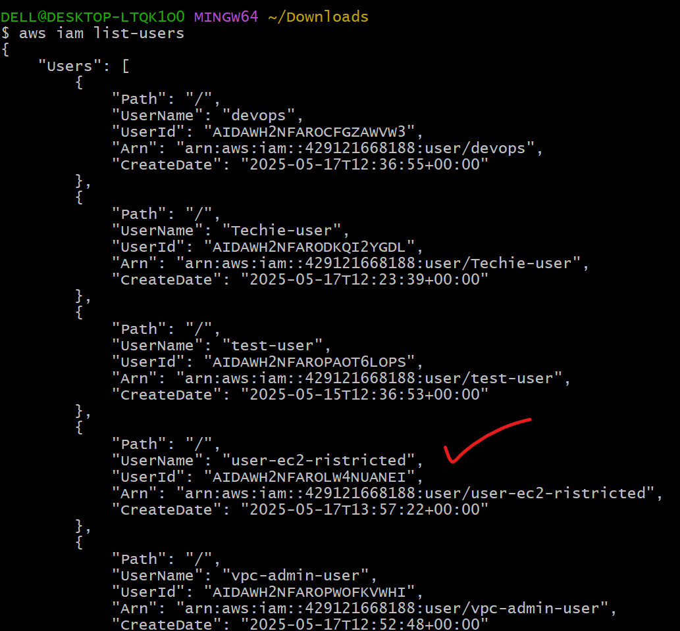

We created a policy that a user can access only this region only, as shown below:

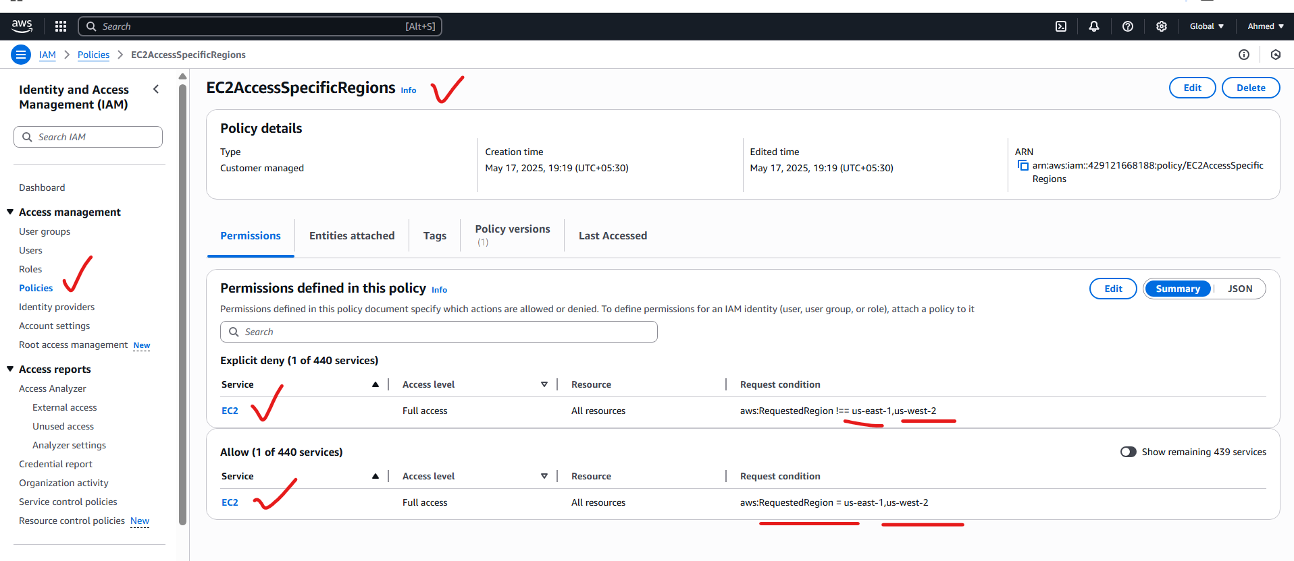

And we attached this policy to “user-ec2-ristricted”: so this user can only access the ec2 in this region only, as shown in the above screenshot

